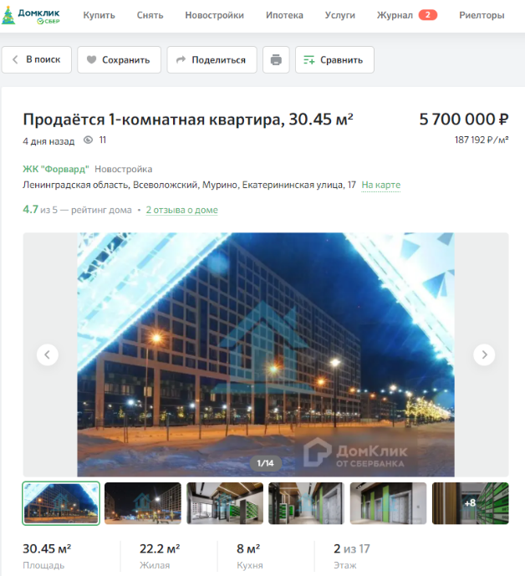
187 192 р/кв.м

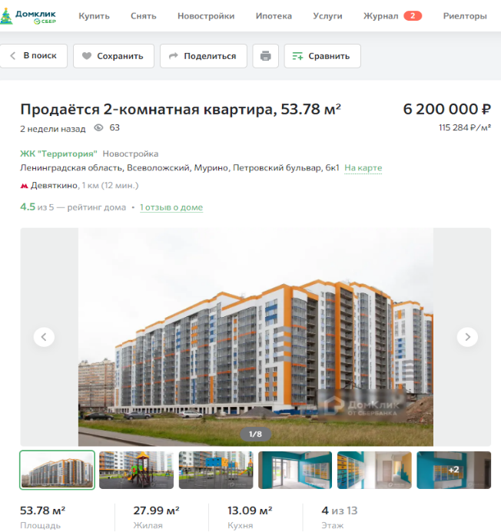

115 284 р/кв.м

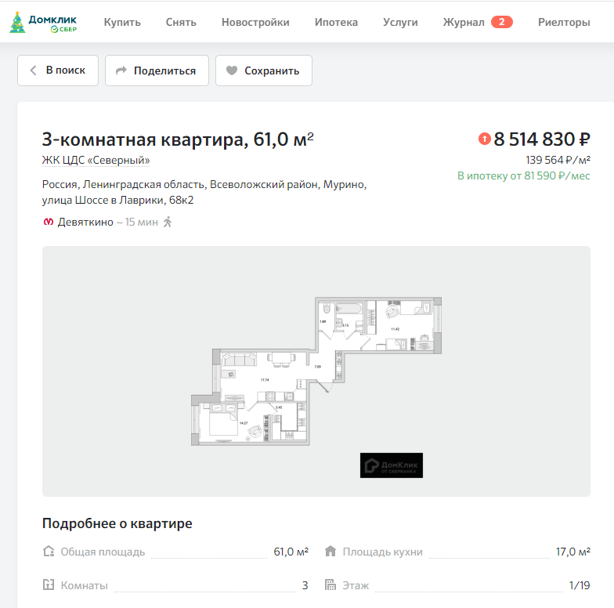

139 564 р/кв.м

$${Ст}_{пер}.ж=\frac{187192+115284+139564}{3}=147346,67руб./{кв}.м.$$
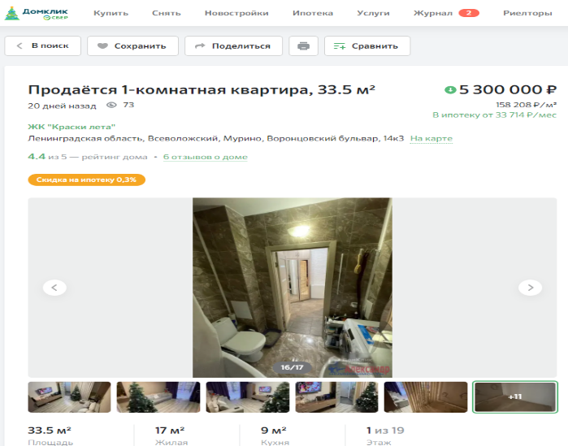
158 208 р/кв.м

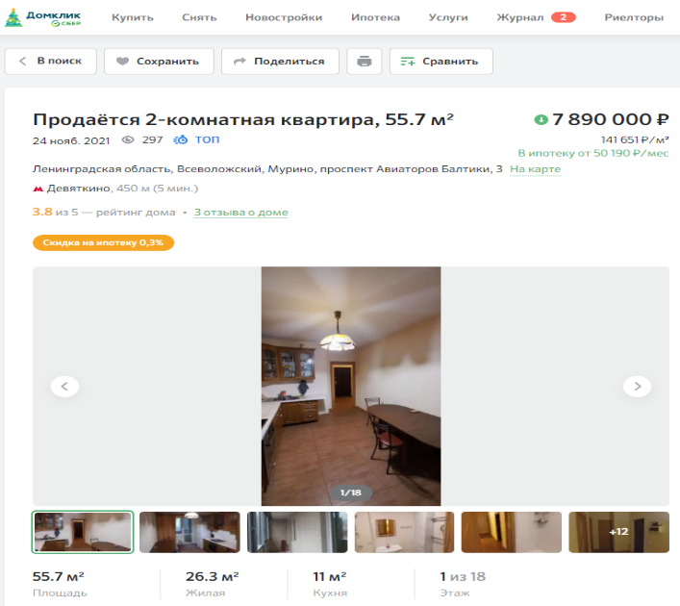

141 651 р/кв.м

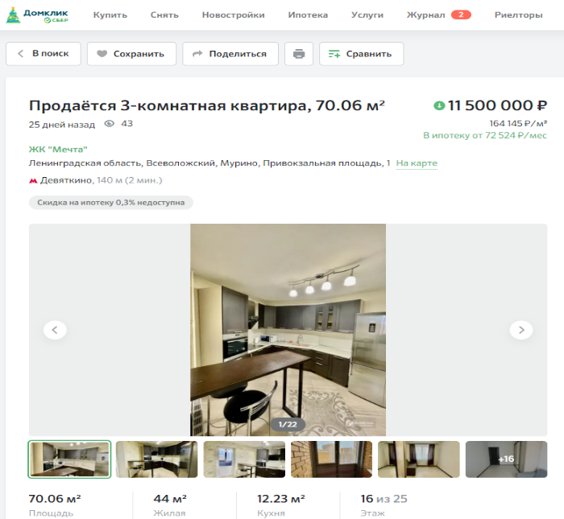

164 145,00 р/кв.м

$${Ст}_{втор}.ж=\frac{158208+141651+164145}{3}=154668руб./{кв}.м.$$
$${Ст}_{кред}=\frac{147346,67+154668}{2}=151007,34руб./{кв}.м.$$

